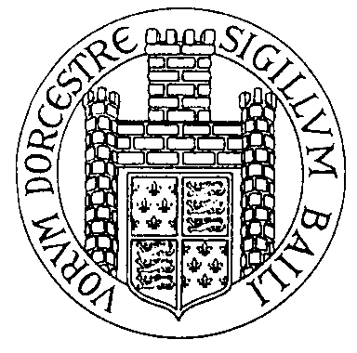 | DORCHESTER TOWN COUNCIL  Council Offices, 19 North Square, Dorchester, Dorset. DT1 1JF  Telephone: (01305) 266861  Adrian Stuart, Town Clerk  e-mail: G.Wakely@dorchester-tc.gov.uk
Wednesday, 4 October 2017

Dear Sir / Madam

Remembrance Parade – Sunday, 12 November 2017

Please find attached the arrangements for the Civic Remembrance Day Service to be held at the War Memorial on Sunday, 12 November 2017. I very much hope you will be able to join us and take part in this year’s commemoration.

The Parade Marshalls, Bill Harper and Chris Knight, will be responsible for forming up the North Square section of the Parade. Please ask your organisation to be at North Square by 10.15a.m. Bill and Chris will identify where you will stand in the Parade. A supply of Orders of Service will be available for collection from the side entrance to the Corn Exchange building whilst the Parade is assembling.

At approximately 10.40a.m the parade will cross into Cornhill and march down South Street and assemble at the War Memorial via the route designated to you by the Parade Marshal and as detailed overleaf. Your standard bearer will parade with you but, as soon as possible after arrival at the War Memorial, they should report to the Marshalls present to assemble to the South of the War Memorial.

Your wreath layer should march with the Wreath Laying party, rather than with your organisation. The party will parade down in a body rather than with their organisations. If your wreath layer is going straight to the War Memorial they should assemble on South Walks outside Direct Moves.

After the service, on the instruction of the Parade Marshall, the Parade will return via Trinity Street. The Mayor will take the salute outside number 20 Trinity Street. The Parade will then continue on up Trinity Street, where it will be dismissed. (The Youth Organisations will process down New Street into South Street where they will be dismissed).

It would be helpful if each unit on parade could provide a parade marker for duty at The Junction. Parade markers should report to the Marshall at the War Memorial no later than 10.35a.m.

Please complete and return the attached form by Monday, 30 October 2017. If you have any questions before you complete it please do not hesitate to get in touch.

Yours faithfully

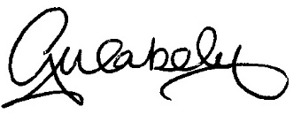

Georgina Wakely

10.30am | The Durnovaria Silver Band will play music at the War Memorial.
10.30am | The 6th Battalion The Rifles depart the TA Centre via Poundbury Road, Bridport Road and High West Street, turning right into Cornhill to South Street. They will turn right into New Street, left into Trinity Street and left at The Junction into South Walks Road, occupying a position west of the traffic lights at the War Memorial.
10.37am  approx. | When the Rifles contingent is parallel with The Works, the Mayoral party will move off, processing straight down South Street to take up position on the west side of the War Memorial.
10.42am  approx. | When the Mayoral Party is parallel to The Works, the North Square Parade will march off.  The Marching Band will lead the front section of the North Square contingent, The Service Cadets, Ex Service Associations, Public Services and Public Organisations will turn right into New Street and left into Trinity Street. The remainder of the North Square contingent, the wreath layers, youth organisations including St John’s Ambulance and the Scouts will continue straight down South Street.  On arrival at The Junction units will fall in.
10.55a.m. | S E R V I C E led by Reverend Canon Thomas Woodhouse, Rector of Dorchester and The Winterbournes.
11.25am  approx. | At the conclusion of the Service, the Parade will remain at attention whilst the Mayoral party moves off. A gap sufficient to allow the Mayor and Council time to prepare to take the salute outside Number 20 Trinity Street should be allowed to develop before the TA contingent marches off on the order of the Parade Marshall. The Marching Band will lead all other units in close order, marching down to the first tree behind the War Memorial and wheeling round to the right to then return back to the Junction and in to Trinity Street.  The Durnovaria Silver Band will again play music at the War Memorial.
11.35am | The Mayor and Council will take the salute outside Number 20 Trinity Street.
11.45am | The TA Centre based unit will return to the TA Centre via High West Street, Bridport Road and Poundbury Road; other units apart from the Youth Organisations will parade to the Plaza Cinema in Trinity Street where they will be dismissed, The Youth Organisations will parade down New Street into South Street where they will be dismissed.
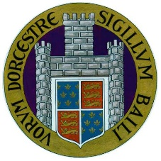
DORCHESTER TOWN COUNCIL
Council Offices, 19 North Square, Dorchester, Dorset. DT1 1JF
Telephone: (01305) 266861
g.wakely@dorchester-tc.gov.uk
PLEASE COMPLETE IN BLOCK CAPITALS

NAME OF ORGANISATION

NAME OF CHAIRMAN / LEADER/ PRESIDENT

WHO TO CONTACT

NAME |  |  |  | POSITION
ADDRESS
TELEPHONE NUMBER |  |  |  | EMAIL ADDRESS
HOW MANY PEOPLE WILL REPRESENT YOUR ORGANISATION?

ARE YOU ABLE TO PROVIDE A PARADE MARKER? |  |  | YES |  |  |  | NO
WILL A REPRESENTATIVE LAY A WREATH? |  |  | YES |  |  |  | NO
WILL YOUR ORGANISATION CARRY A STANDARD? |  |  | YES |  |  |  | NO

The information you have provided on this form will be held and used by Dorchester Town Council and may be shared with outside bodies such as the local press. By signing this form, you agree for your information to be kept and shared.

Signed:

Date:

